Resource Description Language Serialization

# Exercise 1

As discussed in previous classes, RDF can be serialized in several syntaxes.

RDF has an historical XML syntax and several other syntaxes: Turtle, TriG, JSON-LD, N-Triples, N-Quads[1].

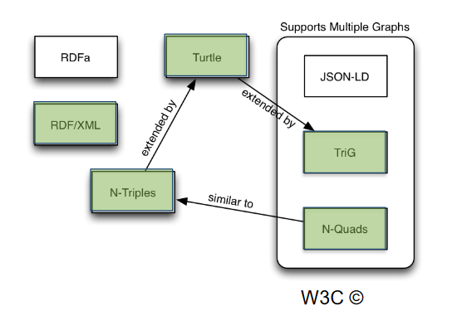

To explore some of these syntaxes, go to RDF [Translator](https://www.easyrdf.org/converter) and experiment transforming RDF data from one syntax to another!

<https://www.easyrdf.org/converter>

For instance, consider transforming the following RDF graph in the RDF/XML syntax:

<rdf:RDF xmlns:rdf="http://www.w3.org/1999/02/22-rdf-syntax-ns#" xmlns:feup ="http://fe.up.pt/schema#" >

  <rdf:Description rdf:about="http://fe.up.pt/lsf/doc.html">

  <feup:author>

    <rdf:Description

      rdf:about="http://fe.up.pt/liliana.ferreira#me">

        <feup:firstName>Liliana</feup:firstName>

      </rdf:Description>

    </feup:author>

    <feup:theme>Web</feup:theme>

  </rdf:Description>

</rdf:RDF>

Go to [RDF Translator](https://www.easyrdf.org/converter) and transform it.

After, use the [W3C Validation service](https://www.w3.org/RDF/Validator/) to validate the previous RDF excerpt and analyse its content.

# Exercise 2

Describe, in your own words, what has been described or stated in the following RDF document. Try to draw the RDF graph using the following notation: ellipses for resources, labelled arrows for properties, and rectangles for values.

You can leave the ellipses for blank nodes empty. You may use TURTLE’s notation for language and datatype tags inside the rectangles.

<?xml version="1.0"?>

<rdf:RDF

xmlns:rdf="http://www.w3.org/1999/02/22-rdf-syntax-ns#"

xmlns:geography="http://www.example.org/geography#"

xmlns:rdfs="http://www.w3.org/2000/01/rdf-schema#" >

<rdf:Description rdf:about="http://www.example.org/geography#Brussels">

<geography:capitalOf rdf:resource="http://www.example.org/geography#Belgium"/>

<geography:name xml:lang="fr">Bruxelles</geography:name>

<geography:name xml:lang="nl">Brussel</geography:name>

<geography:name xml:lang="en">Brussels</geography:name>

<rdf:type rdf:resource="http://www.example.org/geography#City"/>

</rdf:Description>

<rdf:Description rdf:about="http://www.example.org/geography#Belgium">

<rdf:type rdf:resource="http://www.example.org/geography#Country"/>

</rdf:Description>

</rdf:RDF>

# Exercise 3

Translate the RDF/XML document from the previous exercise into TURTLE using the given RDF translator. Don’t forget to validate the result.

# Exercise 4

Extend the TURTLE file you have created in the second exercise with:

• The population of Belgium; choose an appropriate predicate and datatype.

• The population of Brussels; choose an appropriate predicate and datatype.

• The introduction of another country and capital.

1. RDF 1.0 and 1.1 serialization formats, W3C <http://www.w3.org/TR/rdf11-new>